**Lab01 Report**

1. I compensate my probes in this order; First I plugged my probe to the digital oscilloscope and set to auto set After that I observe that may probe is over compensated and in order to fix it I used with the black tool(control stick) which comes with the probe. Finally I obtained square wave graphic
2. I prepared my system which means signal generator is giving 5 Vp-p sinusoidal signal with a 1 kHz frequency. After that First I used positive edge triggering and I obtained fig.1

fig.1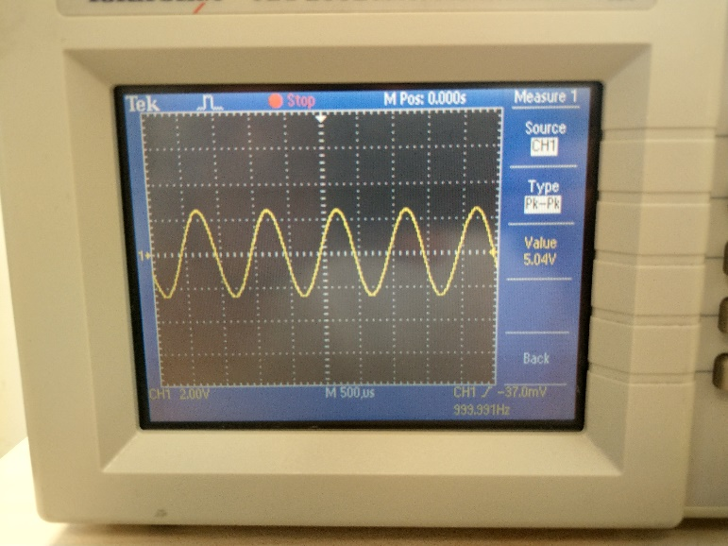

After obtaining that I changed to negative edge triggering and I obtained fig.2

fig.2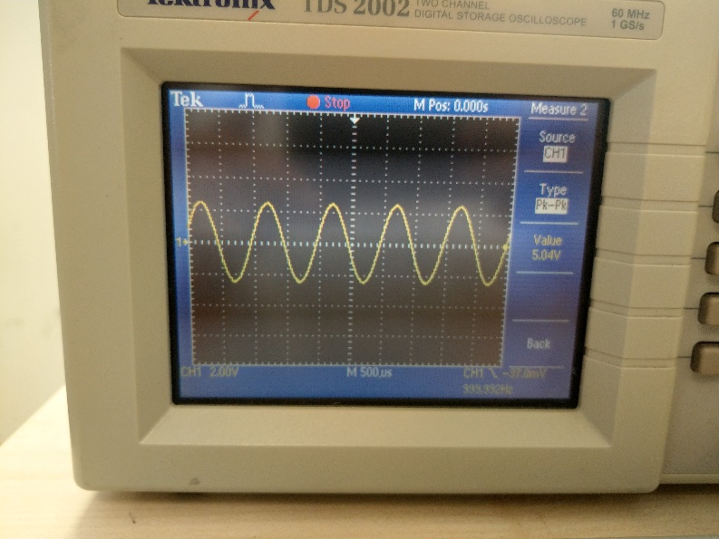

and after observing two of them I conclude that changing negative /positive trigger mode is chancing how oscilloscope is trigged in the way it is fallin or rising at that point and because of that we have diplayed slightly different graphics

1. I prepare my setup as giving 1Vp-p with 2 kHz frequency of triangular wave. After that I change the trigger level knob on the oscilloscope and I observe that when I am raising the trigger mode oscilloscope cannot display the graph because it is not reaching the trigger level and when I am decreasing the level it is diplaying the graph as it should be.
2. I prepare my setup as giving 1Vp-p with 5 kHz frequency of square wave. Then I select all of the acquisition modes which are sample, peak detect and average modes. First I used Sample mode which showed me waveform points (fig.3). After I used peak detect mode which shows and I obtained fig.4 which showed me the stored peak point on the normal graph. And finally I used averge mode and I obtained fig.5 which shows me more stable graph because it stroes the average points.

fig.3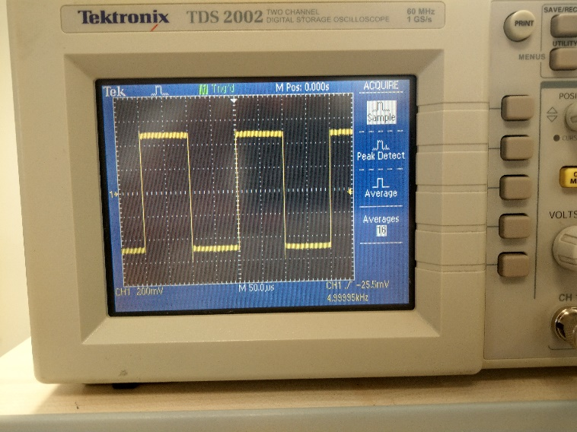

fig.4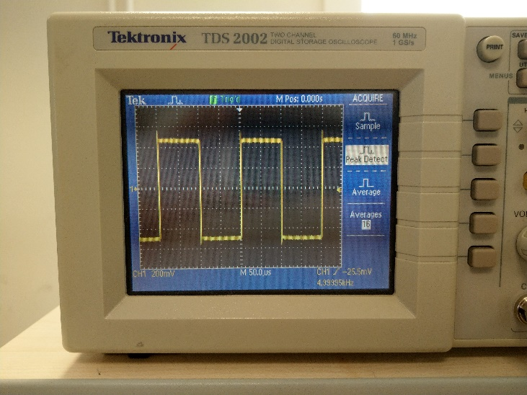

fig.5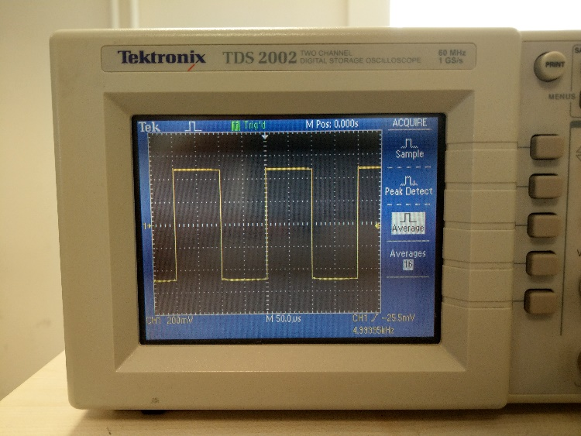

1. I prepare my setup as giving 2Vp-p with 1 kHz frequency of sinusoidol wave and also I apple DC-Offset of 1 V. Than I used DC coupling and obtained fig.6 after I switch the AC coupling I obtained fig. 7. I observe that In DC copling both of the current types is shoen in the graph but in the AC coupling only AC is detecting DC is not.

Fig.6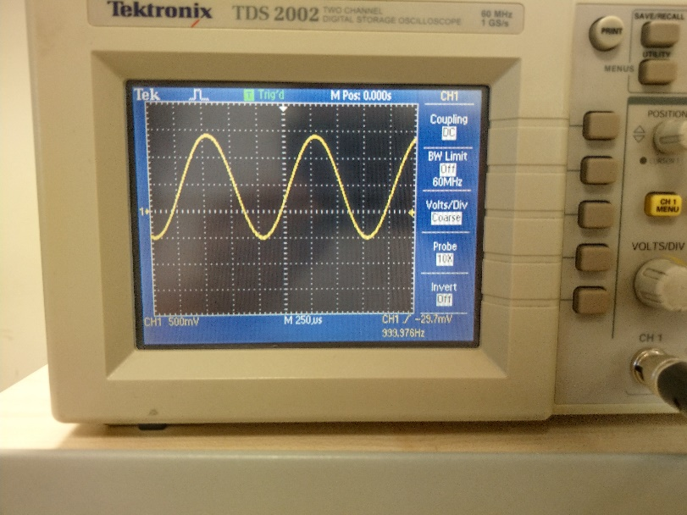

fig.7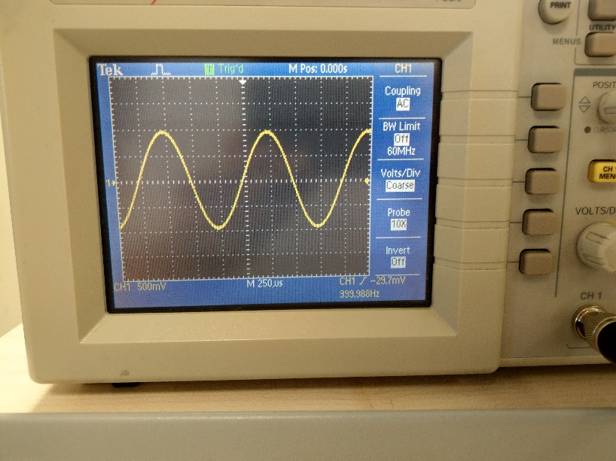

1. I setup the board as it given in the assignment and I prepare my system as giving 2Vp-p with 1 kHz frequency of sinusoidol wave with DC-Offset of 0. I obtained fig.8 and I measuered the time delay 36µ second and phase difference is 12 decrease. After I change to 100 Hz I obtained fig.9 and 1.6 ms time delay and 57 degrease of phase diiference. I observe that this circuit failed at filtering high frequency signal but do well at low freuency signals.

fig.8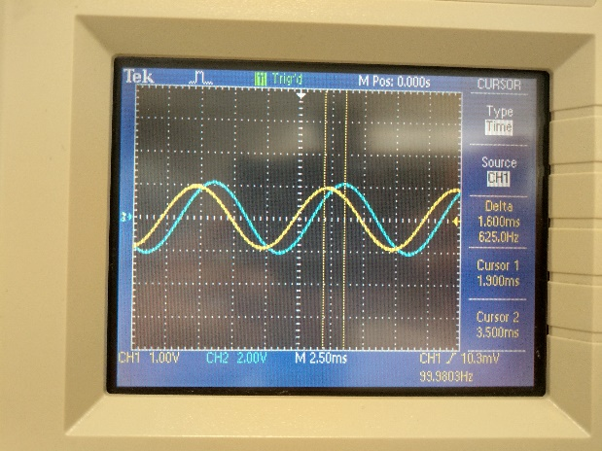fig.9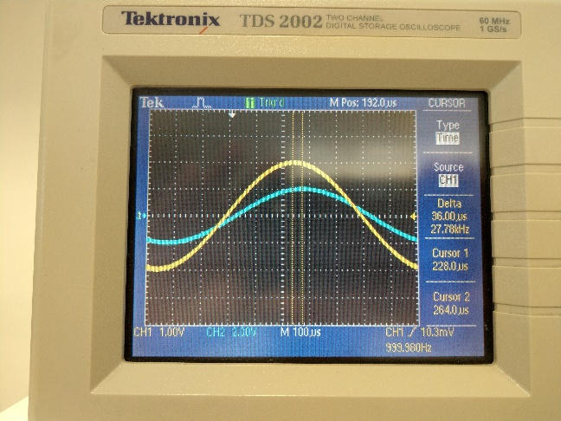

Şevki Gavrem Kulkuloğlu

21601793 section 2